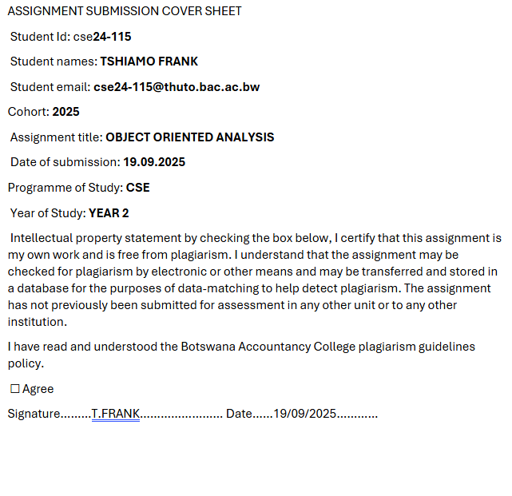

**PART A: SYSTEM DOCUMENTATION INSTRUCTIONS**

**FUNCTIONAL REQUIREMENTS**

1.What features should be available in the system?

There is Customer side and Employee side. The employee can log in and out of the system. When a customer logs in the employee should be able to capture the customer's details and capture account details and associate them with the customer. They should be able to view the customers' details. Employees should be able to view the customer's transactions details.

2. Should the system support online transactions/ only physical? How do transactions work?

Since this is a desktop, the transactions will only be physically. Customers can deposit and withdraw funds from their accounts. Customers can transfer funds between accounts or to other customers. Transaction history includes timestamps, amounts, and descriptions.

3.What information is required during customer registrations?

IDs are required mostly. Because of passport numbers by foreigners, we need some so that it can be easy for the KYC and be able to identify them easily. Information like occupation is also needed. This information can also help employees so they can generate reports, including total transactions for a month, deposits, withdrawals, and account summaries.

**NON-FUNCTIONAL REQUIREMENTS**

1.What is the expected time for transactions?

The most expected time when interacting with the system is milliseconds. The system is expected to be fast and reliable.

2.What security measures are expected?

primarily we have the these two that is each user of the system will log into the system through usernames and passwords which are stored in the database and the password policy that minimum length of.8 alphanumeric characters and then also we expect the data to be encrypted when it's stored in the database, meaning when I look physically without using the Java application, the text should be scrambled. But it's only when I'm using the system that I should be able to see the details, account and financial information or customer data of the customer.

3.Should the system be mobile compatible?

No, it's simply a desktop application.

**Date: 18.09.2025**

**Interviewee: Lecture (Themba Moeng)**

**Topic Discussed: Employee functionalities, Reporting and transaction**

**Key Responses: Log in /out customer management, Registrations, transactions etc.**

**Time: 09:53**

**2.** **Structural UML Modelling**

System Use Case Diagram

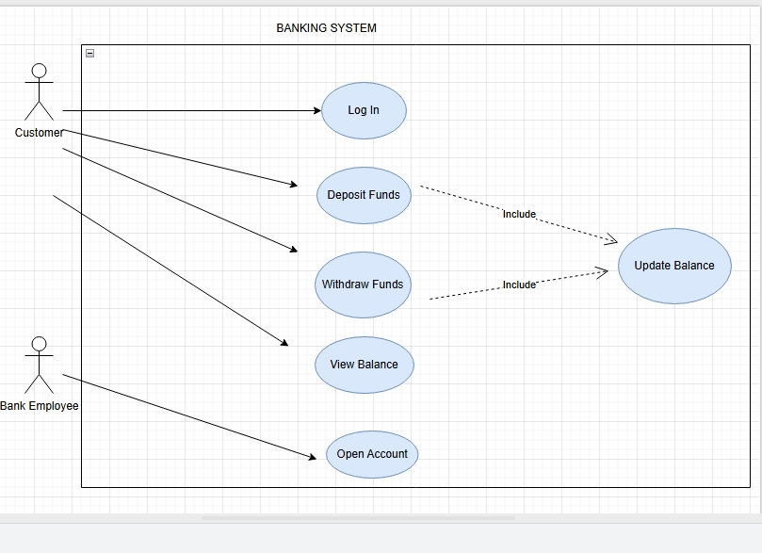

Class diagram

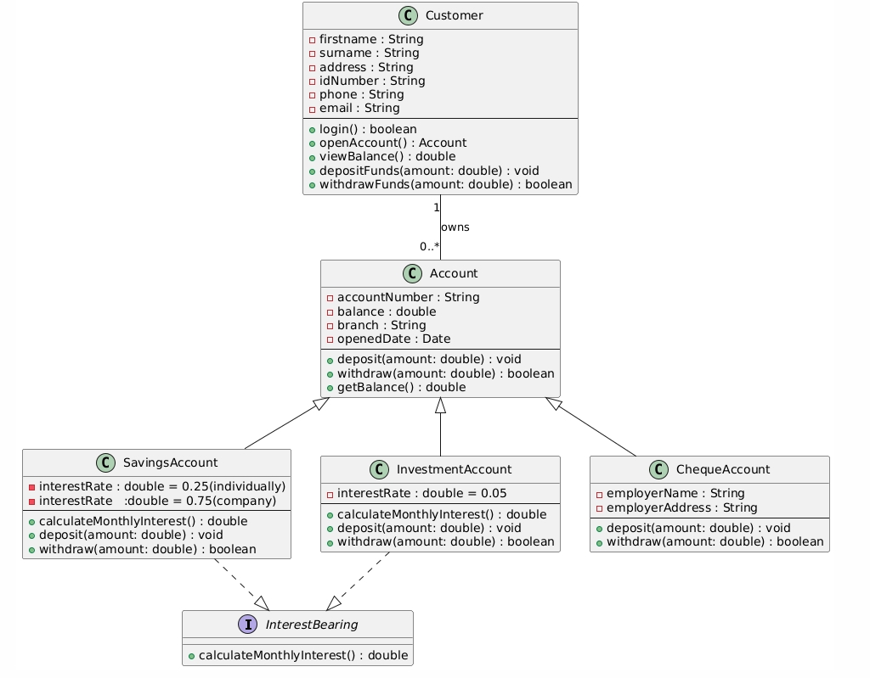

3. Behavioral UML Modelling)

Sequence Diagrams

Login Diagram

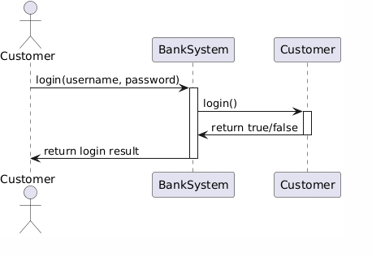

Deposit Funds

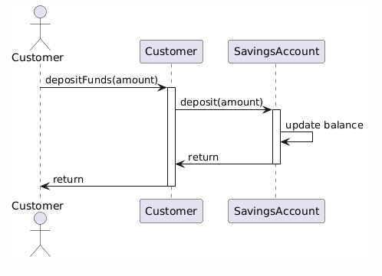

State Diagram

